Recommendation 3: A holistic evidence-based prevention plan
Recommendation 3 requires Ambulance Victoria to develop a comprehensive prevention plan targeting discrimination, sexual harassment, bullying, victimisation and other harmful workplace conduct. Prevention measures will be most effective if informed by the workforce and relevant stakeholders, who understand the operating environment, the culture on the ground and what prevention measures will have the best prospects of success.

Recommendation intent and why it matters
A prevention plan demonstrates the organisation’s commitment to a safe and respectful workplace and sends a strong message rejecting harmful conduct. A holistic evidence-based prevention plan will help Ambulance Victoria to meet its Equal Opportunity Act 2010 (Vic) positive duty to prevent unlawful conduct. A prevention plan is a document that employers can use to outline how they will comply with the positive duty, including by identifying and responding to risk factors contributing to harmful workplace conduct.
A prevention plan will also support Ambulance Victoria to foster a safe workplace by eliminating or reducing the risk of harm and stopping workplace harm before it occurs. The Commission considers that it is reasonable and proportionate for an organisation of Ambulance Victoria’s size to require leaders and managers to ensure the plan is implemented and effective at eliminating unlawful conduct as far as possible.
The Commission has identified 6 minimum standards that organisations must meet to comply with their positive duty to eliminate discrimination, sexual harassment and victimisation, all of which should be included in a prevention plan. To effectively prevent unlawful conduct, it is necessary to address the drivers and risk factors specific to Ambulance Victoria.
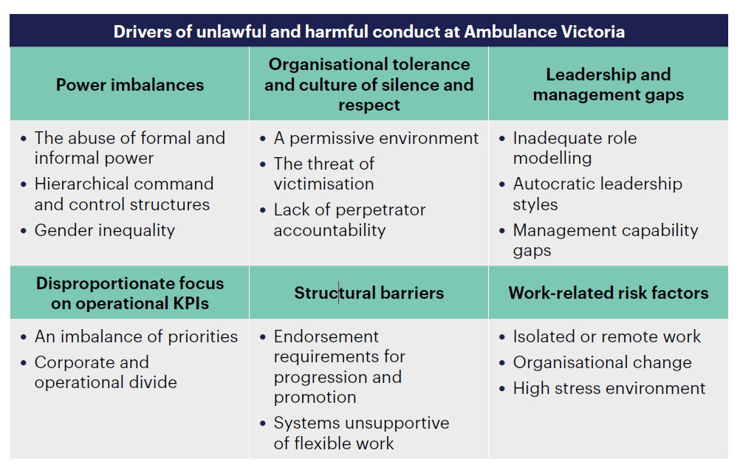

Findings

What we found in Phase 1 of the Review
The Commission found that while Ambulance Victoria had a range of measures in place to prevent unlawful conduct, it lacked a comprehensive, evidence-based approach to prevention. The Commission also found that Ambulance Victoria’s prevention approach was limited by the absence of any prior comprehensive analysis of the key drivers or risk factors for discrimination, sexual harassment, bullying and victimisation.
The Commission found that many Ambulance Victoria employees had directly experienced discrimination, sexual harassment, bullying or victimisation at work:
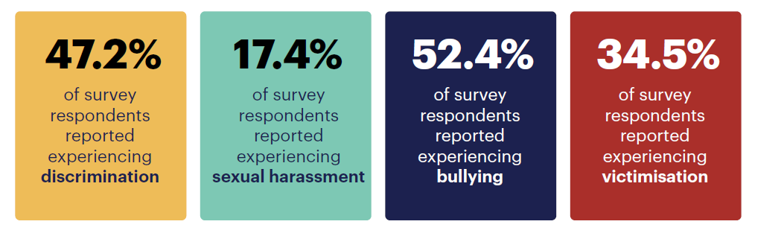
Further information can be found in chapters 7–9 of the Phase 1 Report.

What we found in Phase 3 of the Review
Ambulance Victoria did not develop a prevention plan within 6 months of the publication of Volume II of the Phase 1 Report as required by Recommendation 3
Ambulance Victoria has been developing a prevention plan since 2022 and had a commitment in its Your AV Roadmap to deliver the plan by 30 June 2023. However, Ambulance Victoria delayed launching the plan to align with development of the organisation’s Psychosocial Risk Management Framework – with both documents to be integrated into the one plan.
The Prevention Strategy: Targeting Workplace Discrimination, Sexual Harassment, Bullying and Victimisation (Prevention Strategy) was approved at the August 2024 Ambulance Victoria Board meeting.
The Commission was unable to seek feedback from the workforce (via either focus groups or the workforce survey) on the Prevention Strategy as it was not approved at the time of the Progress Evaluation Audit research.
The Prevention Strategy addresses some of Recommendation 3 at a high level only
The Prevention Strategy attempts to describe actions to address the specific drivers and risk factors identified in Volume I of the Phase 1 Report (Recommendation 3a); however, only at a high level. For example, foundational actions listed for addressing power imbalances are: values refresh; reduce entrenched acting roles; diversity and inclusion plans; improved workplace conditions; and people management and leadership training. There is no further detail or reference to timeframes in which these actions might be undertaken.
Ambulance Victoria reports that it has engaged and consulted on the development of the Prevention Strategy with groups including the Staff Reference Group, relevant internal governance committees, regional directors, WorkSafe, the Commission for Gender Equality in the Public Sector, unions and the Commission (Recommendation 3b). Ambulance Victoria has provided evidence of internal consultation; however, as the Prevention Strategy was not approved when the Commission undertook interviews and focus groups during this Progress Evaluation Audit, the Commission could not verify external consultation.
Ambulance Victoria’s Gender Equality Action Plan (GEAP) is referenced in the Prevention Strategy. However, it is unclear how prevention measures in the Prevention Strategy and in the GEAP are integrated. This is the same for the referenced Reflect Reconciliation Action Plan and the Accessibility Action Plan (Recommendation 3c).
The Prevention Strategy describes, at a high level only, some accountabilities for leaders and managers. The document lacks specific, measurable, achievable, relevant and time-bound (SMART) actions/controls. The Prevention Strategy describes Ambulance Victoria’s commitment to regularly reviewing the controls listed in the Prevention Strategy. Yet the Prevention Strategy is unclear on who has responsibility to lead implementation and only references a now non-existent role (Executive Director Equality and Workplace Reform) as accountable for several controls (Recommendation 3d).
The Commission is concerned about page 13 of the Prevention Strategy, which outlines possible action options for people who witness unlawful and harmful workplace behaviour. This seems to be an attempt to address points (a)(i) and (ii) of Recommendation 8: Encouraging a ‘speak up’ culture. However, given the Upstander program has not yet been rolled out, releasing this advice around diffusing and calling out behaviour may create a risk of harm to bystanders in the absence of supporting education and tools.
Ambulance Victoria has not taken a proactive approach to preventing workplace harm
Concerningly, the Commission found that Ambulance Victoria, in implementing Recommendation 3 and related recommendations including Recommendation 6: Improving safety in isolated environments, has taken a more reactive rather than a proactive approach to safety and prevention in the workplace.
Ambulance Victoria’s workforce reported missed opportunities to prevent workplace harm
As identified in the original Review, without a comprehensive prevention plan there are missed opportunities to clarify everyone’s role in preventing harmful conduct, engage and educate the workforce, and ensure visibility and accountability of prevention activities.
This is reflected in the Progress Evaluation Audit workforce survey findings as per the following graph:

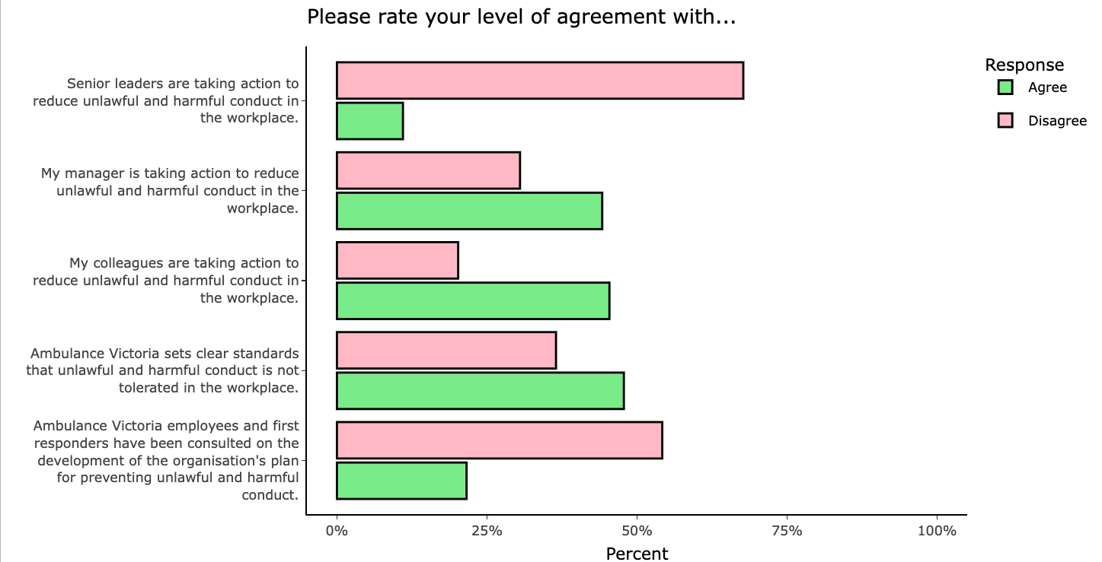

There are mixed survey results for respondents feeling safe in the workplace in relation to unlawful conduct:
- sexual harassment – 60%
- discrimination – 37%
- victimisation – 36%
- bullying – 32%.

Progress in achieving change
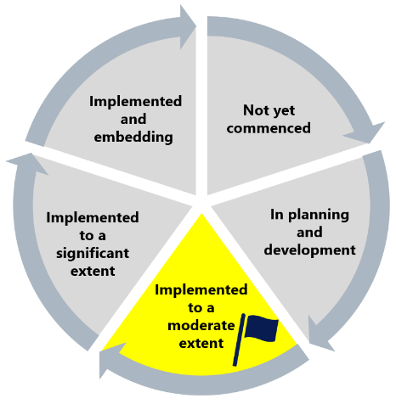
The Commission finds that this recommendation has been implemented to a moderate extent.
As identified in Phase 1 of the Review, without a comprehensive prevention plan there are missed opportunities to clarify everyone’s role in preventing harmful conduct, engage and educate the workforce, and ensure visibility and accountability of prevention activities.

What measures are still needed?
Successfully implementing the intent of Recommendation 3 will also be dependent on Ambulance Victoria’s implementation of other Progress Evaluation Audit safety and prevention recommendations, including:
- Recommendation 6: Improving safety in isolated environments
- Recommendation 8: Encouraging a ‘speak up’ culture and
- Recommendation 9: Contact officers and local champions network.
These recommendations have been assessed by the Commission as ‘implemented to a moderate extent’, ‘not yet commenced’ and ‘in planning and development’ respectively. There is an opportunity for Ambulance Victoria to holistically consider the shared intent of these recommendations and implement them in a way that creates strong synergies between reforms.
The Commission notes that Ambulance Victoria’s prevention work also aligns with implementation of other recommendations that do not form part of this Progress Evaluation Audit, including Valuing those who care (Recommendation 10), Disrupting harmful stereotypes (Recommendation 26) and Fully embedding workplace safety and equality in risk management and health and safety systems (Recommendation 39).
Achieving these changes will enable Ambulance Victoria to foster a culture of prevention – a crucial factor in reform. See Reform Enabler: Culture Of Prevention.

Note that percentages for each question may not sum to 100% because neutral responses are not included.

