Recommendation 14: Enhancing perceptions of independence and supporting capability for the new organisational response to reports and complaints of unlawful conduct
Recommendation 14 requires several steps to rebuild trust and confidence in Ambulance Victoria’s report and complaint system. These include appointing an external director to oversee the redesign and implementation of the new report and complaint system. In relation to Recommendation 14(d), the Professional Standards and Behaviours Department (PSBD) reports to the CEO (note: Ambulance Victoria established the PSBD within the Office of the Chief Executive, a change endorsed by the Commission in December 2022).
Additionally, at least half of the staff in this system should be recruited from outside Ambulance Victoria to bring fresh ideas and avoid pre-existing relationships. The new model should report directly to the chief operations officer, ensuring a distinct and impartial structure. Finally, the new system must be adequately resourced to effectively address unlawful and harmful conduct, as past issues were partly due to insufficient resources.

Recommendation intent and why it matters
Strengthening and rebuilding workplace trust and confidence in the reporting and complaint system help to create a safe and supportive environment where members of the workforce are encouraged to come forward with their experiences of unlawful or harmful conduct or conduct that they have witnessed or learnt about. An independent and capable response to reports and complaints of unlawful and harmful conduct will in turn support Ambulance Victoria to discharge its legal obligations.

Findings

What we found in Phase 1 of the Review
Despite a significant number of employees and first responders reporting experiencing discrimination, sexual harassment, bullying and victimisation in Ambulance Victoria, the Commission found that very few had formally reported the conduct. Many of those who came forward and shared their experiences with the Commission overwhelmingly described feeling dissatisfied with the report and complaint system. Many said they had felt unsupported and, at times, retraumatised by their experiences with the system. The report and complaint system was not perceived to deliver fair, impartial and quick resolution of reports and complaints.
[The complaint process] has nearly ended my marriage, I’m out of pocket upwards of fifty thousand dollars due to lost wages and I’m a different person. I’m withdrawn, anxious, nauseated thinking about going to work, constantly on edge when at work and can’t go near the room where my uniform is kept when on days off.
Phase 1 Participant

What we found in Phase 3 of the Review
Ambulance Victoria has implemented parts (a), (b) and (d) of the recommendation
Establishing the new PSBD forms Ambulance Victoria’s response to this and related complaint recommendations.
In relation to Recommendation 14(a) and (b), the Commission found that position descriptions for each role have been developed reflecting the key attributes, skills and expertise necessary for staff in complaint-handling roles. The position descriptions also include the range of skills and experiences required by the recommendation.
However, at the time of PSBD establishment only 4 positions out of 22 were filled.
Due to a higher than expected case load, part (c) of the recommendation is at risk of not being met
The Commission found that the PSBD’s data collection and reporting have identified that the PSBD is receiving more complaints than forecast, resulting in an increase in the number of active complaints. In the 2024 financial year, Ambulance Victoria reported there were 624 complaints, representing 10% of the workforce (306 of these were closed during the financial year).
It has also been flagged within Ambulance Victoria that high complaint ratios for case managers and investigators negatively impact the PSBD’s ability to deliver a person-centred and trauma-informed report and complaint system as designed.
PSBD establishment documentation noted a risk that the PSBD is not adequately resourced to deliver expected outcomes. The mitigation for this risk was to utilise an external provider on a temporary basis. At the time of the Progress Evaluation Audit, due to budget constraints additional resources had not been secured and the PSBD instead was applying a strict scope and referring all matters deemed appropriate for local management to local areas, with support from People and Culture to manage these.
Complaints of incivility are referred by the PSBD to local management for resolution, but local managers are not well equipped to resolve these matters
Data from the PSBD shows that a significant proportion of complaints are assessed as incivility or interpersonal conflict (for example, of the 62 reports in March 2024, 52% were assessed as interpersonal conflict). Ambulance Victoria told the Commission that where a complaint is assessed as incivility by the PSBD Assessment Committee, it is referred to local management for resolution. The rationale given was that where the particulars of a proven complaint are not assessed as falling within the legal definition of bullying and harassment, it is assessed as incivility and suitable for local management to resolve. The Commission understands that referral to local management is being utilised by the PSBD more broadly to try and manage the increase in complaint volume.
If the organisation invests in the uplift and capacity of our frontline leaders, then in the long term, you won't need the extra resources in Professional Standards, because staff won't be going there because it's getting dealt with by the leaders at the frontline.
Participant
However, it was also identified by the workforce, organisational leaders and the Commission that managers are not always equipped with the capability to effectively locally manage issues like incivility. Relatedly, members of the workforce with management roles raised concerns that they sometimes feared performing what would be considered reasonable management action because it could result in a complaint of bullying or harassment made against them and they were concerned about not being supported by senior leaders in performing reasonable management action. This was also reflected in the workforce survey as per the following graph.
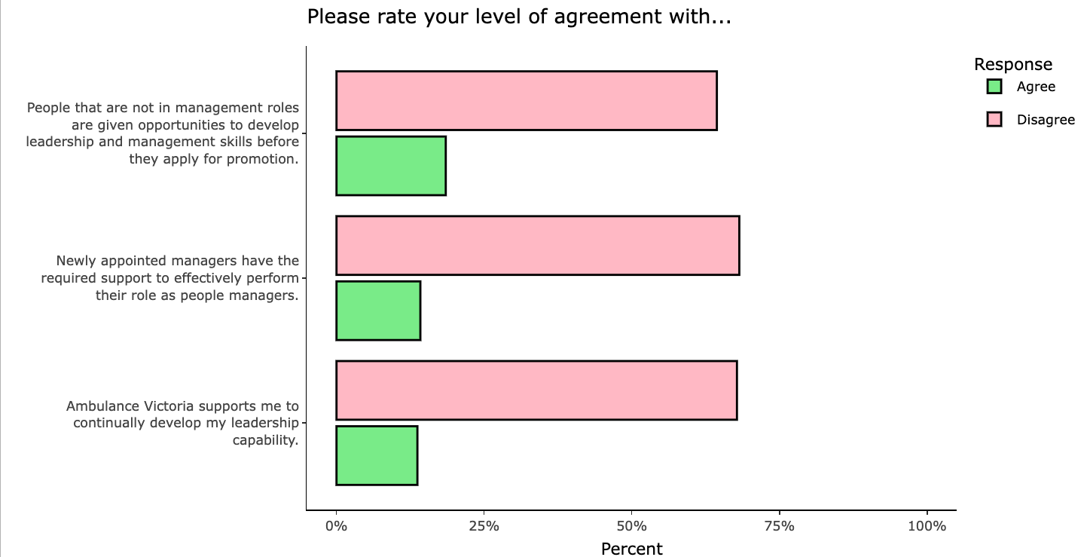

Equipping people who have management responsibilities with the capability and support to resolve issues outside of the scope of the PSBD will both reduce PSBD caseload and benefit the broader workforce. There is evidence that this is happening to some extent – of the workforce survey respondents who had participated in the Leading Together program (related to Recommendation 37: Embedding sustained learning and development):
- 59% reported that what they learnt will help them to be more effective at constructively resolving conflict at work
- 83% reported that they know how to adapt their leadership style to suit different situations.
The Leading Together program is a start and is having positive impacts, but further and sustained work will be required to sufficiently build the capability of leaders and managers.
My concern is that we actually need to do an uplift in our staff … setting the tone in your branch rather than just shipping everything off as an email to the PSBD, because that's overwhelming them and it's not necessary for low-level stuff, for some things it obviously is, but then chokes up their system … you know, a short conversation that's done and dusted in five minutes at the time and appropriately documented as opposed to, you know, what, a three-, four-month process of the PSBD reviewing you. That's harmful to people and it doesn't need to be.
Participant
Positively, the Commission found that members of the workforce are more likely to come forward if they experience unlawful behaviour
Part of the rationale for the establishment of the new complaint system was to help people come forward if they experienced or witnessed unlawful behaviour. This increased willingness is a sign of success and was reflected in in the Commission’s data collection:
We now have a clear understanding of the impact that some of these behaviours and these people exhibiting these behaviours have on others. And therefore, we're not as tolerant of it – with keeping those people in the workplace, if I can put it that way. Yeah, because we don't want them causing so much harm to everyone else.
Participant
Members of the workforce who have made complaints to the PSBD are generally dissatisfied with the complaint-management process, which may be due to insufficient resources
Data obtained by the Commission shows that of the workforce survey participants who reported having made complaints to the PSBD:
- Only 6% were satisfied with the time taken to handle their complaint; 80% were dissatisfied.
- Only 23% agreed that the process had been handled in a person-centred way and only 16% agreed that it had been handled in a trauma-informed way.
See Recommendation 20: Understanding how the report and complaint system is working, which relates to how the report and complaint system is working.

Progress in achieving change
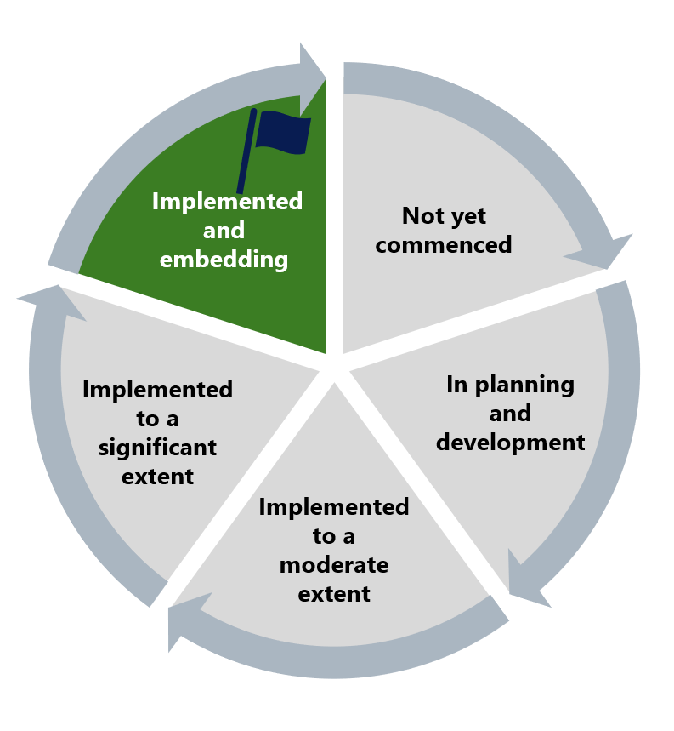
The Commission has assessed this recommendation as implemented but flags a concern that an ineffective response to higher-than-expected PSBD case numbers will undermine the progress made to date in establishing a new organisational complaint and reporting system. The Commission is also concerned about the negative impacts associated with high workloads on the risk of burnout in PSBD staff and management.

What measures are still needed?
To realise the intent of this recommendation and not risk returning to a situation where high proportions of the workforce are unwilling to come forward to report harmful and unlawful conduct because of lack of trust and negative experiences, Ambulance Victoria should consider ways to both effectively resource the PSBD and at the same time build the capability of leaders and managers to resolve issues at the local level.
Implementation of this recommendation, Recommendation 37: Embedding sustained learning and development, Recommendation 3: A holistic evidence-based prevention plan and Recommendation 8: Encouraging a ‘speak-up’ culture is crucial to promoting proactive safety measures and shared responsibility for reforms across all levels and locations of the organisation. See Reform Enabler: Culture of Prevention and Reform Enabler: Distributed Leadership.
‘We're very short focused on our budget at the moment and we can cut the costs and we can not invest in the resources and all the things that we need to do. But what's actually going to happen is it's going to cost us a lot more in the long run. So, we're going to have a lot more WorkCover claims. We're going to have a lot more the time in the Commission and we're going to have a lot more negotiated outcomes and payouts, and we're going to have a lot more legal bills. So, at the end of the day, if we don't actually invest now, the money now, it's actually going to cost us a lot of money in the long term and it's going to do a lot of damage to people as well, I think. And that's everything, that's just not the PSBD stuff, that's across the board.’
Participant

Note that percentages may not add up to 100% for each question as neutral responses are not shown.
Workload is one of the 6 areas of worklife identified in: Michael Leiter and Christina Maslach, ‘Six areas of worklife: A model of the organizational context of burnout’ (1999) 21 Journal of Health and Human Services Administration 21, 472, as organisational contributors to burnout.

